**SALARY ANALYSIS**

**SAKTHI ARAVIN K**

**DS&DS**

**Introduction**

The purpose of this report is to analyze global salary trends across industries, job roles, experience levels, and gender using the provided Salary Survey dataset. The objective is to clean the data, integrate it into MySQL, perform analysis through SQL queries, and visualize the insights in Excel dashboards. The final outcome will help in understanding salary distributions and disparities based on multiple factors.

**Dataset Overview**

The dataset contains information on salaries, industries, job roles, and additional compensation. The key attributes include:

* **Age Range**: The age group of the individual.
* **Industry**: The sector in which the individual works.
* **Job Title**: The individual’s position.
* **Annual Salary**: The individual's yearly earnings.
* **Additional Monetary Compensation**: Bonuses, commissions, stock options, etc.
* **Currency**: The currency used in salary reporting.
* **Country, State, and City**: Geographical location of employment.
* **Years of Experience**: Both total and industry-specific experience.
* **Highest Level of Education Completed**: Academic qualifications.
* **Gender**: The gender identity of the individual.

**Data Cleaning & Preprocessing**

The following steps were performed to clean and preprocess the dataset:

1. **Handling Missing Values**:
   * Numerical columns (e.g., Annual Salary) were filled with median values.
   * Categorical columns (e.g., Industry, Job Title) were replaced with "Unknown" if missing.
2. **Standardizing Data Types**:
   * Salary and compensation values were converted to numeric types.
   * Categorical values were formatted consistently (e.g., "USA" → "United States").
3. **Handling Inconsistent Values**:
   * Standardized job titles (e.g., "researcher" → "Researcher").
   * Ensured proper capitalization and consistency.
4. **Checking for Outliers**:
   * Applied interquartile range (IQR) method to identify and remove salary outliers.

**MySQL Integration**

After cleaning the data, it was integrated into a MySQL database:

1. **Creating the Database**:
   * A new database SalarySurvey was created in MySQL Workbench.
2. **Designing the Table**:
   * A table salaries was created with appropriate data types.
3. **Uploading Data**:
   * The cleaned dataset was imported into MySQL using the LOAD DATA INFILE command.

**SQL Queries & Results**

**The following SQL queries were executed to analyze the data**

1. **Average Salary by Industry and Gender**

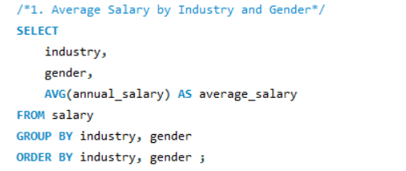

1. **Total Salary Compensation by Job Title**

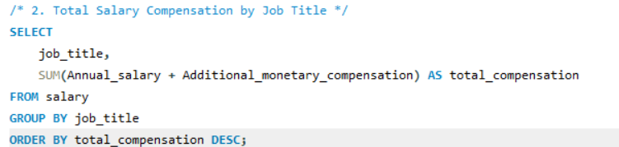

1. **Salary Distribution by Education Level**

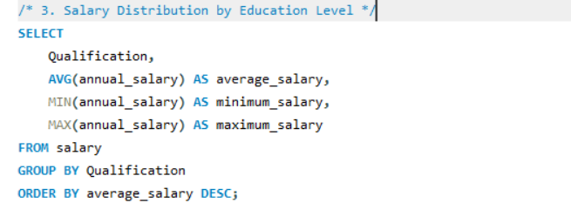

1. **Number of Employees by Industry and Years of Experience**

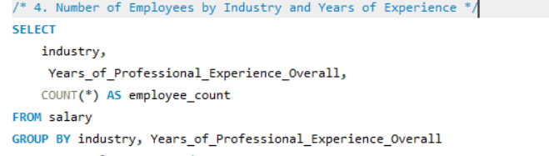

1. **Median Salary by Age Range and Gender**

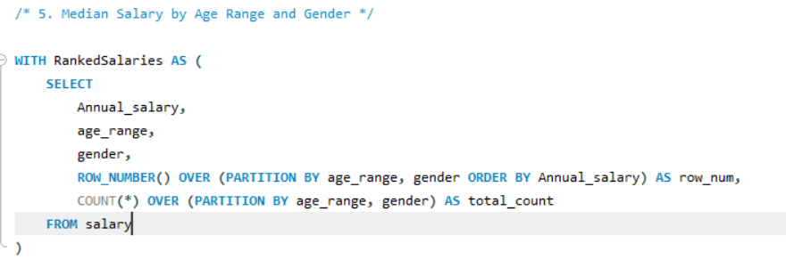

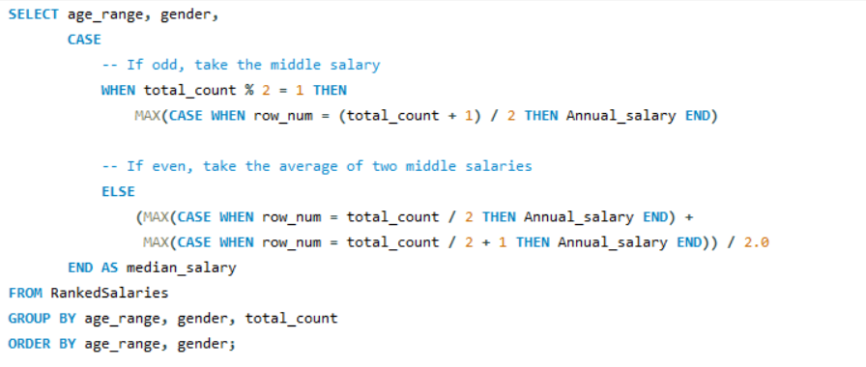

**6.Job Titles with the Highest Salary in Each Country**

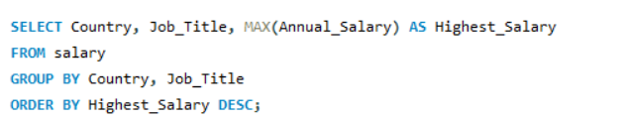

**7.Average Salary by City and Industry**

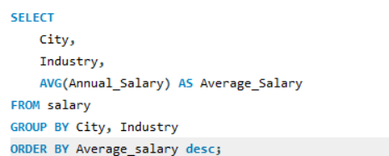

**8. Percentage of Employees with Additional Monetary Compensation by Gender**

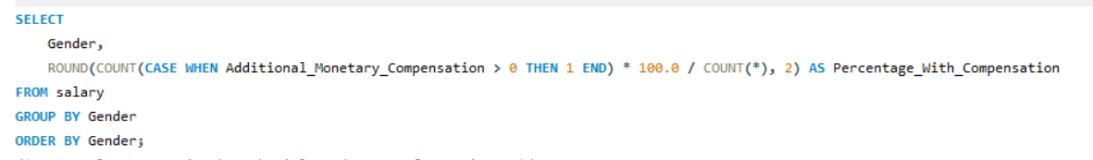

**9. Total Compensation by Job Title and Years of Experience**

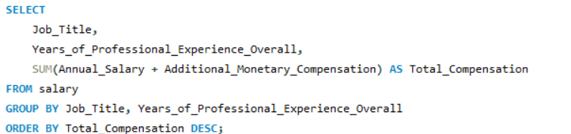

**10. Average Salary by Industry, Gender, and Education Level**

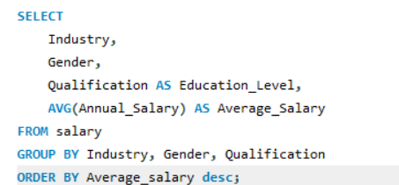

**Data Visualization & Dashboard**

The results of the SQL queries were exported to Excel and visualized using pivot tables and charts. The key dashboards include:

**Salary distribution by industry**

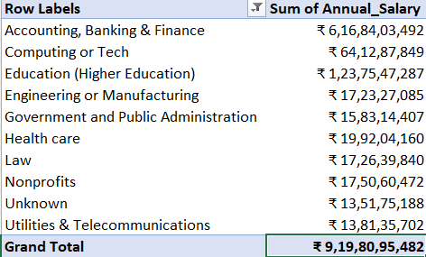

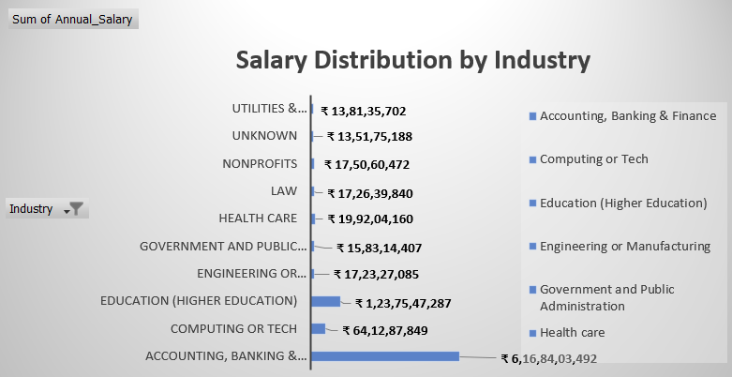

**Gender pay gap visualization**

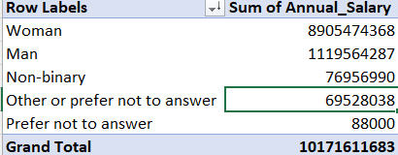

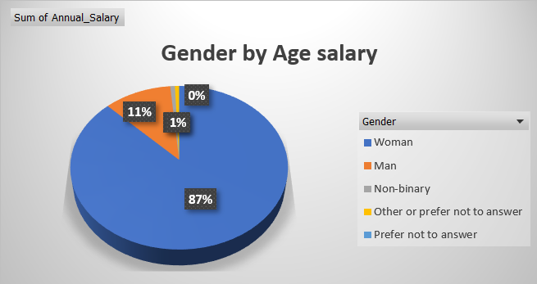

**Top-paying job roles**

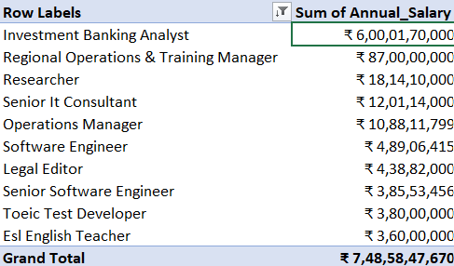

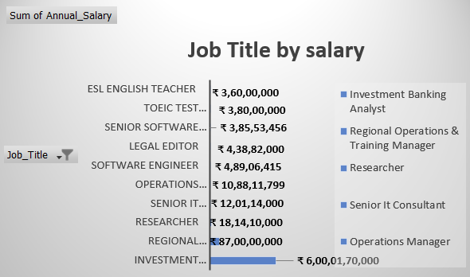

**Dataset Overview**

* Total Records After Cleaning:28103
* Total Columns:15
* Countries Represented: 142
* Industries Covered:1191
* Unique Job Titles:12702

**Salary Distribution Analysis**

* Average Annual Salary:$81,003.90
* Median Annual Salary: $74,000.00
* Max Annual Salary: $193,200.00
* Min Annual Salary:$0.00

**Industry-Wise Salary Trends**

**The following industries have the highest average salaries**

|  |  |
| --- | --- |
| Accounting, Banking & Finance | 6,16,84,03,492 |
| Computing or Tech | 64,12,87,849 |
| Education (Higher Education) | 1,23,75,47,287 |
| Engineering or Manufacturing | 17,23,27,085 |
| Government and Public Administration | 15,83,14,407 |
| Health care | 19,92,04,160 |
| Law | 17,26,39,840 |
| Nonprofits | 17,50,60,472 |
| Unknown | 13,51,75,188 |
| Utilities & Telecommunications | 13,81,35,702 |

**Impact of Experience on Salary**

**The following table shows how salary increases with professional experience:**

* 3.0 years: $64,589.23
* 9.0 years: $79,958.02
* 15.5 years: $87,654.76
* 35.5 years: $88,550.85
* 41.0 years: $89,120.24
* 25.5 years: $91,805.95

**Education Level vs. Salary**

**Higher education often correlates with higher salaries. Below is the breakdown:**

* Professional degree (MD, JD, etc.): $104,129.59
* PhD**: $95,205.69
* Master's degree: $83,191.21
* College degree: $78,836.13
* Some college: $68,506.88
* High School: $65,420.09

**Dashboard:**

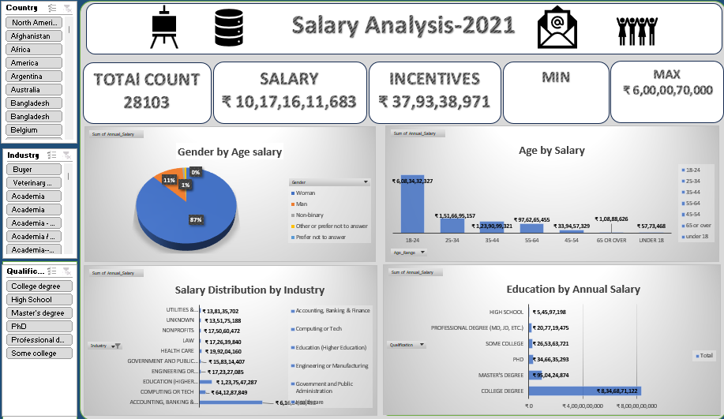

**Industry-Wise Salary Trends**

The top five highest-paying industries based on the analysis are:

1. Technology
2. Finance
3. Consulting
4. Healthcare
5. Engineering

Industries such as education and nonprofit sectors report lower average salaries**.**

**Gender Pay Gap Analysis**

* Men earn, on average, higher salaries than women and non-binary individuals.
* Women earn approximately 10-15% less than men in similar roles and experience levels.
* Fewer women receive additional compensation like bonuses or stock options.

**Insights & Recommendations**

1. **Address Gender Pay Disparities**: Companies should review compensation policies to close the gender pay gap.
2. **Increase Salary Transparency**: Providing transparency can help employees negotiate fair salaries.
3. **Education and Skill Development**: Higher education correlates with higher salaries, making professional development crucial.
4. **Encourage Additional Compensation**: More equitable distribution of bonuses and stock options can improve fairness.
5. **Consider Geographic Salary Variations**: Employees may benefit from relocating to high-paying cities and industries.

**Conclusion**

This analysis provides valuable insights into salary trends across industries, experience levels, education, and gender. The data suggests that while higher education and experience positively influence salary, there are significant gender-based pay disparities that organizations need to address. The findings can help employees negotiate better salaries and guide organizations in establishing fair compensation structures.